PyQT5 MySQL Example

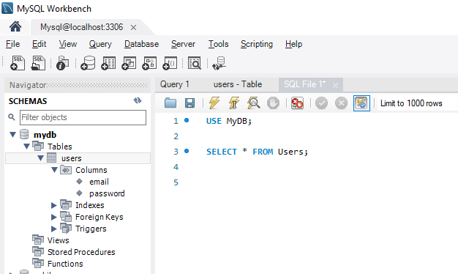

|  |  |
| --- | --- |
|  | |
| **Line** | **Code** |
| **1**  **2**  **3**  **4**  **5**  **6**  **7**  **8**  **9**  **10**  **11**  **12**  **13**  **14**  **15**  **16**  **17**  **18**  **19**  **20**  **21**  **22**  **23**  **24**  **25**  **26**  **27**  **28**  **29**  **30**  **31**  **32**  **33**  **34**  **35**  **36**  **37**  **38**  **39**  **40**  **41**  **42**  **43**  **44**  **45**  **46**  **47**  **48**  **49**  **50**  **51**  **52**  **53**  **54**  **55**  **56**  **57**  **58**  **59**  **60**  **61**  **62**  **63**  **64**  **65**  **66**  **67**  **68**  **69**  **70**  **71**  **72**  **73**  **74**  **75**  **76**  **77**  **78**  **79**  **80**  **81**  **82**  **83**  **84**  **85**  **86**  **87**  **88**  **89**  **90**  **91**  **92**  **93** | **from** PyQt5 **import** QtCore, QtGui, QtWidgets  **import** mysql.connector **as** mc  **class** Ui_Form(**object**):  **def** setupUi(self, Form):  Form.setObjectName("Form")  Form.resize(519, 207)  self.verticalLayout = QtWidgets.QVBoxLayout(Form)  self.verticalLayout.setObjectName("verticalLayout")  self.horizontalLayout = QtWidgets.QHBoxLayout()  self.horizontalLayout.setObjectName("horizontalLayout")  self.label = QtWidgets.QLabel(Form)  self.label.setObjectName("label")  self.horizontalLayout.addWidget(self.label)  self.lineEditEmaul = QtWidgets.QLineEdit(Form)  self.lineEditEmaul.setObjectName("lineEditEmaul")  self.horizontalLayout.addWidget(self.lineEditEmaul)  self.verticalLayout.addLayout(self.horizontalLayout)  self.horizontalLayout_2 = QtWidgets.QHBoxLayout()  self.horizontalLayout_2.setObjectName("horizontalLayout_2")  self.label_2 = QtWidgets.QLabel(Form)  self.label_2.setObjectName("label_2")  self.horizontalLayout_2.addWidget(self.label_2)  self.lineEditPass = QtWidgets.QLineEdit(Form)  self.lineEditPass.setObjectName("lineEditPass")  self.horizontalLayout_2.addWidget(self.lineEditPass)  self.verticalLayout.addLayout(self.horizontalLayout_2)  spacerItem = QtWidgets.QSpacerItem(20, 40,  QtWidgets.QSizePolicy.Minimum, QtWidgets.QSizePolicy.Expanding)  self.verticalLayout.addItem(spacerItem)  self.pushButton = QtWidgets.QPushButton(Form)  self.pushButton.setObjectName("pushButton")  # connected clicked signal of button with insert_data method  self.pushButton.clicked.connect(self.insert_data)  self.verticalLayout.addWidget(self.pushButton)  self.labelResult = QtWidgets.QLabel(Form)  font = QtGui.QFont()  font.setPointSize(14)  font.setBold(**True**)  font.setWeight(75)  self.labelResult.setFont(font)  self.labelResult.setText("")  self.labelResult.setObjectName("labelResult")  self.verticalLayout.addWidget(self.labelResult)  self.retranslateUi(Form)  QtCore.QMetaObject.connectSlotsByName(Form)  Form.setWindowTitle('New User Registration')  **def** insert_data(self):  **try**:  mydb = mc.connect(  host="localhost",  user="Student",  password="P@$$w0rd",  database="MyDB"  )  mycursor = mydb.cursor()  email = self.lineEditEmaul.text()  password = self.lineEditPass.text()  sql = "INSERT INTO users (email, password) VALUES (%s, %s)"  val = (email, password)  mycursor.execute(sql, val)  mydb.commit()  self.labelResult.setText("Data Inserted")  **except** mc.Error **as** e:  self.labelResult.setText("Error Inserting Data")  **def** retranslateUi(self, Form):  _translate = QtCore.QCoreApplication.translate  Form.setWindowTitle(_translate("Form", "Form"))  self.label.setText(_translate("Form", "Email"))  self.label_2.setText(_translate("Form", "Password:"))  self.pushButton.setText(_translate("Form", "Insert"))  **if** __name__ == "__main__":  **import** sys  app = QtWidgets.QApplication(sys.argv)  Form = QtWidgets.QWidget()  ui = Ui_Form()  ui.setupUi(Form)  Form.show()  sys.exit(app.exec_()) |